Муниципальное бюджетное общеобразовательное учреждение
средняя общеобразовательная школа с. Камышки
Александрово-Гайского района

Research work:
«Unusual English Traditions»

Student: Kulakhmetova Renata, Form 8.
Teacher: Beresneva N.V.
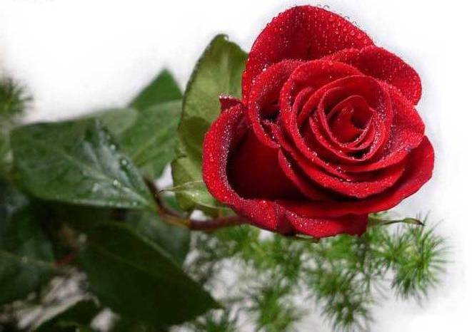

2014г.

Contents:

- The History of Great Britain 3
- Unusual traditions: 4
  - Halloween
  - Morris Dance
  - Pearly Kings and Queens
- Topic “English Customs and Traditions” 7

- Conclusion. 9
- The List of Literature. 10

The History of Great Britain
Great Britain, United Kingdom of Great Britain and Northern Ireland - a state in north -west Europe in the British Isles. In ancient times the British Isles Picts lived tribes. Under the name of one of the tribes of the Britons, the country was named Britain. With the Norman Conquest began forming nation. In 1212, an uprising barons forced King John to sign the Magna Carta. This marked the beginning of the development of the British monarchy as the estate. In the reign of Elizabeth I (1558-1603) England, defeating the Spanish fleet has achieved dominance at sea. Elizabeth changed Scottish kings of the Stuart dynasty, Scotland united with England and became her personal union. The English Revolution of the 17th century resulted in the establishment of a parliamentary monarchy. Long struggle with France ended in the 18th century with British victory. Throughout the 19th century Britain expanded its empire, though deprived of the United States. In the 1940-1970 gained independence almost all British colonies. UK pursues independent policy in relation to other European countries, largely focusing on the United States.

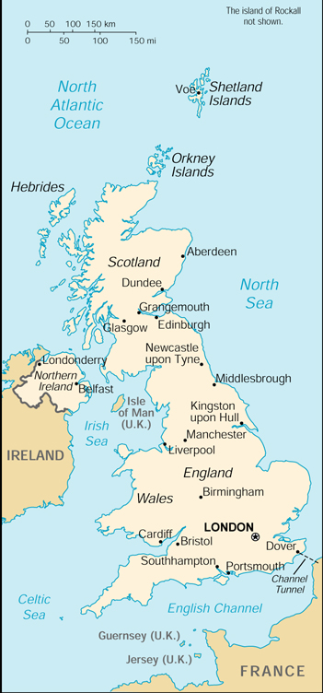
English Unusual Traditions.
Halloween.
The History of Britain is very diverse - Britain has repeatedly won the other countries and met with defeat. Over the past century in the United Kingdom formed many interesting and sometimes more than a country of traditions and festivals. Of course, the customs and traditions of Great Britain are the subject of many stories and as many legends. One of the most popular, exciting and mysterious as the holidays - Halloween. On this New Year holiday cling. October 31 of each year, before the Day of All Saints, children dress in a fantastic, scary costumes and go from house to house, collecting tribute - candy and various sweets, scaring off on proverbs, all evil.

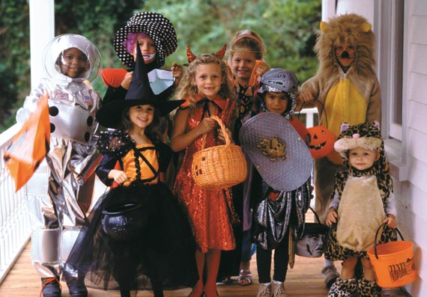

Morris Dance.
Morris dance - one of the traditional English dances. This dance hits fast and reminds reel and jig. Spectators celebrate not only the beauty of dance, but also its complexity, accompanied by music and executable only by men. There could be no more than five. Dance like a game match and executed, respectively, only men. They were dressed in special clothes, as well as on their hands they should have been or white handkerchiefs or sabers.
British sincerely believe that this dance brings happiness and dancers and spectators.

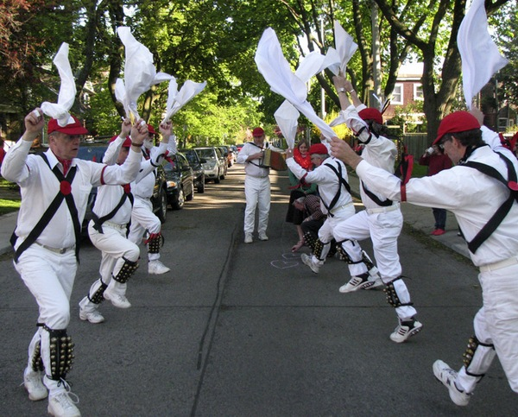

Pearly Kings and Queens.
Such an unusual " pearl " tradition has a long history : the first time the idea to attract attention with an unusual costume originated Henry Croft back in 1875. After graduating from the orphanage 13 -year-old Henry worked as a janitor guy admired guild street vendors who did not leave each other in trouble collecting the money on something to help their colleagues get up on their feet. " Mother of pearl " (as traders called their "union" ) wore embroidered with pearl buttons , as it not only helps to " identify their own" , but at the same time and served as a good advertisement for buyers.

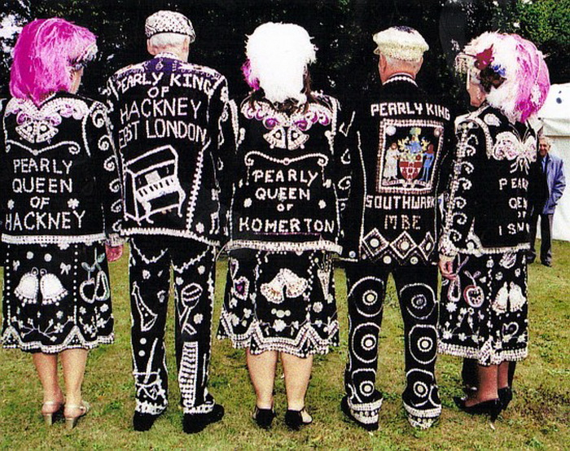

"English Сustoms and Traditions"
If you want to know more about the history of life of different countries you must study there traditions. English people carefully keep up their traditions. Many of them are connected with the capital of Great Britain - London. Thus every night the traditional ceremony of the keys takes place at the famous London Tower. At 9.53 p.m. the Chief Warder, carrying the Bloody Tower, where the present guard is waiting for them "Halt! Who goes there?" - the guards ask. Keys, marches from one Tower to another, locking the gates. The escort follows him. Then they march to the Chief Warder answers: "Queen Elisabeth's keys". "Advance, Queen Elisabeth's keys. All's well. " - they are answered. At 10 sharp the Chief Warder proceeds to the Queen's house to return the keys from the Tower. It is a tradition with English people to celebrate holidays. Christmas, Easter, Halloween, Guy Fawkes Night, St. Valentines Day, etc. Christmas is more important for Englishmen than any other holiday. People travel from all parts of the country to be with their families on the 25-th of December. English people decorate Christmas trees with flashing lights, wrapping paper, glass balls, bake puddings and traditional Christmas Turkey. They decorate their houses with holly and mistletoe. Children wait for the presents from Santa Claus, a mythical man, who lives in the North pole and makes toys for children. On Christmas he visits the homes of good children and lives them presents in their socks. Children put their socks at the foot of the bed or a fireplace. Another colorful holiday is Halloween. It is celebrated for hundreds of years. On this day children dress in funny ghostly costumes and knock at the neighbor's doors. After shouting "Trick or treat" they get gifts of candy or money. But more than 2000 years ago it wasn't a merry holiday. It was the time when the Lord of Dead gathered the souls of dead and presented them to Druid Heaven on October 31. So people thought that all the evil forces appeared in the darkness on that day. To frighten them people made fires. So nowadays Englishmen take turnips, potatoes, pumpkins, cut holes in them and place candles inside. There is one more holiday, which has a great significance especially for young lovers it is the St. Valentine's Day. It is celebrated on the 14-th of February. Valentine's Day is sweethearts' day when people in love express their affections for each other. The message is - "Will you be my Valentine?" Valentines used to be for young lovers, but nowadays grandparents, cousins and friends of any age express their affection through a small gift or a card. The customs of celebrating St. Valentine's Day dates back to the festivals called Lupercalia. There were games and dancing girl who would be his sweetheart for the coming year. It was a pagan custom, but it survived when Christianity came. In the 7-th century it got the name St. Valentine's Day. St. Valentine's had had a long and romantic history. The Romans carried it to England as a pagan festival, combined with the Christian religion, it formed a good tradition. Nowadays Valentine's Day is celebrated in many countries of the world. Mostly the gifts of cards and flowers are presented on that day. These are the most exiting holidays in England, I think. As we can see they make the life of people richer and happier, make them feel proud of their country, its history and culture.

Conclusion.

I believe that every English tradition is very diverse and unusual in its. Every country has its own traditions and customs. In Britain traditions play a very important role in the life of people. The British are proud of their traditions and keep them carefully.

The List of Literature.

http://znayuvse.ru/
http://www.kulturologia.ru/
http://to-name.ru/historical-events/velikobritania.htm

